Deliverable D01: Workgroup Report

-

Group E8.02

## 

Github Repository: <https://github.com/JStockwell/Acme-One-E8.02>

Members:

* Gregorio Ortega Soldado ([greortsol@alum.us.es](mailto:greortsol@alum.us.es))
* Alejandro Manuel Gestoso Torres ([alegestor@alum.us.es](mailto:alegestor@alum.us.es))
* Jaime Stockwell Mendoza ([jaistomen@alum.us.es](mailto:jaistomen@alum.us.es))
* Pablo Aurelio Sánchez Valenzuela ([pabsanval1@alum.us.es](mailto:pabsanval1@alum.us.es))
* Manuel Cabra Morón ([mancabmor1@alum.us.es](mailto:mancabmor1@alum.us.es))
* Fernando Claros ([ferclabar@alum.us.es](mailto:ferclabar@alum.us.es))

## Fecha: 27/02/2022

# Table of Contents

| 1. Executive Summary 2. Revision Table 3. Introduction 4. Content    1. Workgroup Members    2. Formal Agreement    3. Self-Evaluation Methodology    4. Termination Clause    5. Signatures 5. Conclusions | 2  2  3  3  3  4  4  5  5  5 |
| --- | --- |

# Executive Summary

Lorem ipsum dolor sit amet, consectetur adipiscing elit, sed do eiusmod tempor incididunt ut labore et dolore magna aliqua. Ut enim ad minim veniam, quis nostrud exercitation ullamco laboris nisi ut aliquip ex ea commodo consequat. Duis aute irure dolor in reprehenderit in voluptate velit esse cillum dolore eu fugiat nulla pariatur. Excepteur sint occaecat cupidatat non proident, sunt in culpa qui officia deserunt mollit anim id est laborum.

# Revision Table

| Revision | Description | Date |
| --- | --- | --- |
| v1.0 | Initial Creation | dd/mm/YYYY |

# 

# Introduction

This report contains all of the formal agreements and self-evaluation systems that will be in place during the whole of the project's duration. The goal of such a document is to allow an easy introduction to the team in charge of the project, our outlook and predictions for the project and our self-evaluation methodologies.

# Content

## Workgroup Members

The E8.02 group is comprised of 6 members, all coursing the English class of Design and Testing 2.

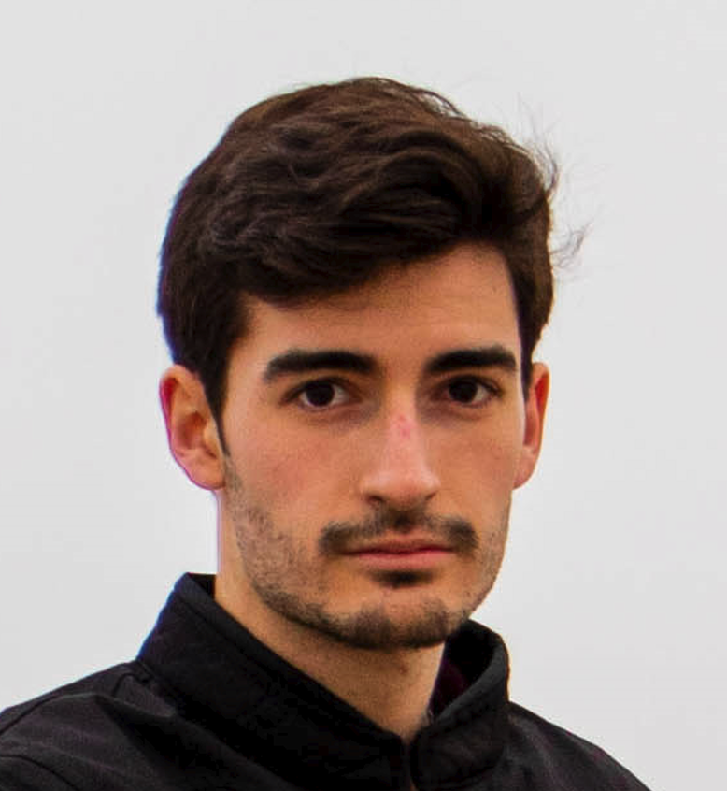

Gregorio Ortega Soldado

[greortsol@alum.us.es](mailto:greortsol@alum.us.es)

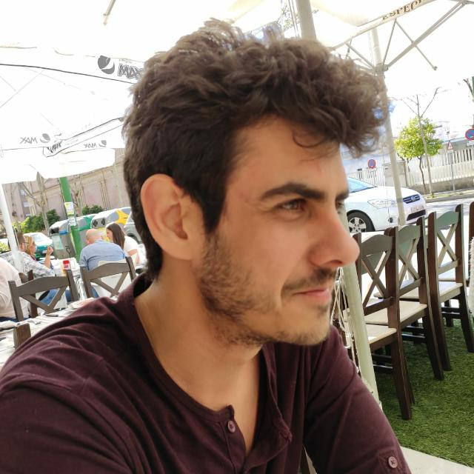

Alejandro Manuel Gestoso Torres

[alegestor@alum.us.es](mailto:alegestor@alum.us.es)

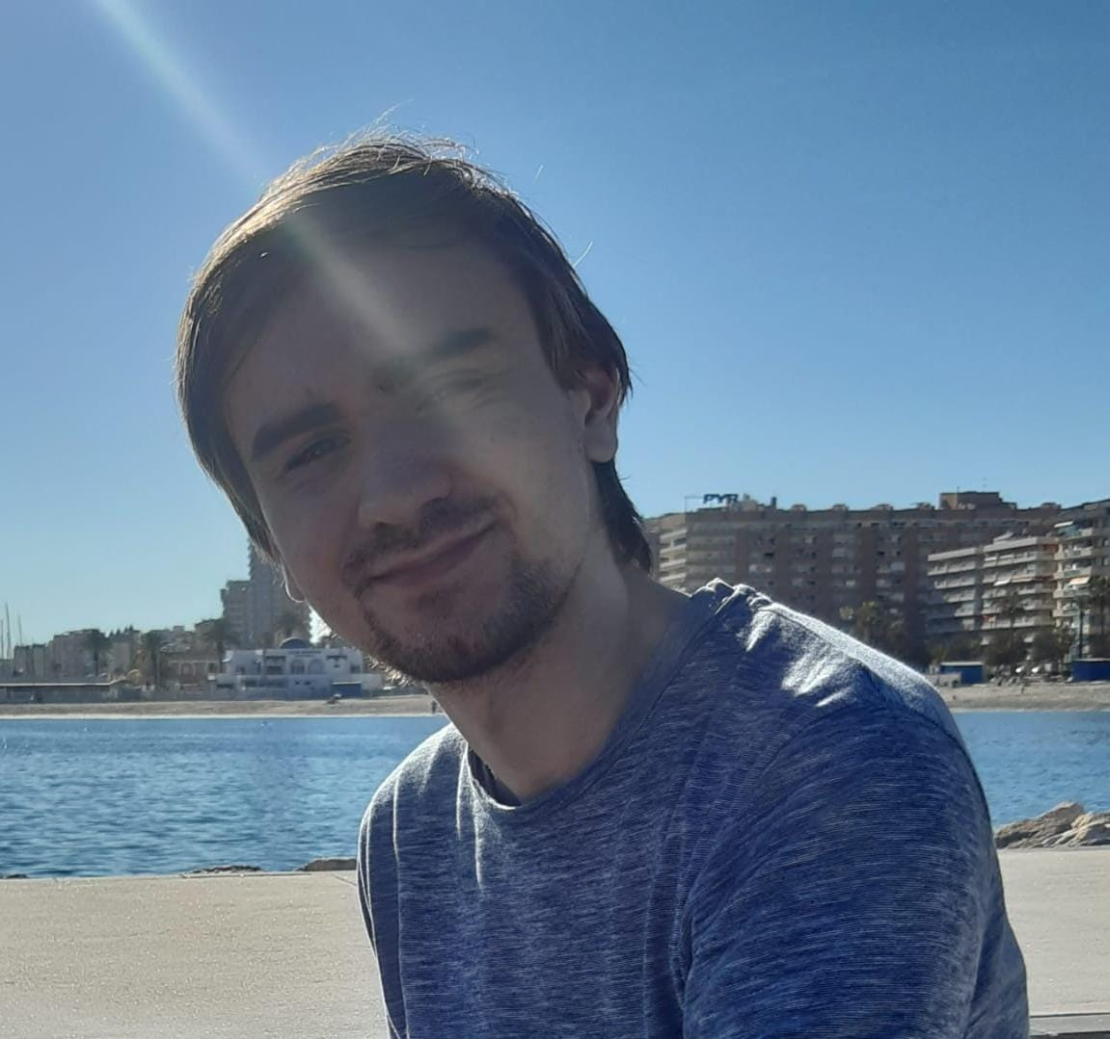

Jaime Stockwell Mendoza

[jaistomen@alum.us.es](mailto:jaistomen@alum.us.es)

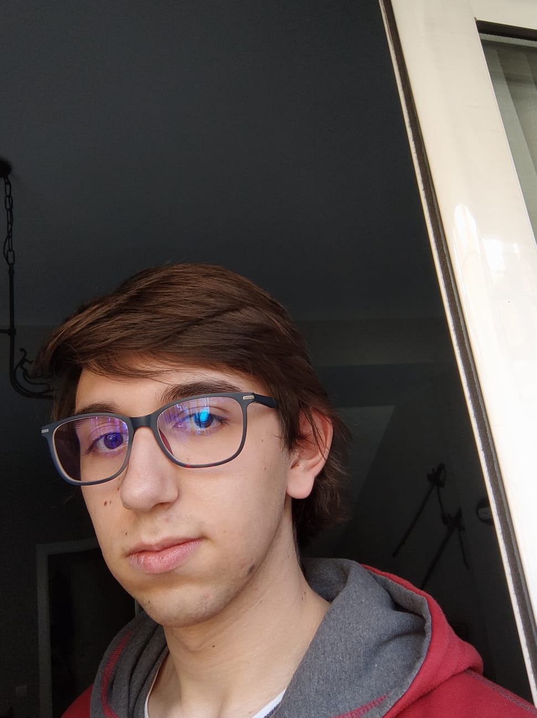

Pablo Aurelio Sánchez Valenzuela

[pabsanval1@alum.us.es](mailto:pabsanval1@alum.us.es)



Manuel Cabra Morón

[mancabmor1@alum.us.es](mailto:mancabmor1@alum.us.es)



Fernando Claros

[ferclabar@alum.us.es](mailto:ferclabar@alum.us.es)

## Formal Agreement

We, the E8.02 group, have read and understand the given syllabus for Design and Testing 2. After much deliberation, we have decided that we are going to attempt to achieve a 9 out of 10 mark in the final evaluation.

## Self-Evaluation Methodology

We will assign user story points using the poker system. With this in mind, we will set a weekly goal of user story points that must be met by each of the members of the group. As we are still a small group, we are open to reconfigure points assignments as the development continues or maintain external criteria in a case by case setting.

* Performing well: Complete all his story points. Does extra story points.
* Performing badly: Does not complete all his story points, does not attend the meetings.

As such, the outcomes from the performance of each member are:

* Reward: Less minimum story points assigned for the following week.
* Punishment: Extra minimum story points assigned for the following week.

## Termination Clause

If a team member completes less than 50% of the minimum story points in a period of 1 month, the rest of the team are in their right to remove them from the project. A reunion will be called with the rest of the team with and without the affected member to discuss the situation. At the end, the remaining members will vote on the decision.

## Signatures

Jaime Stockwell Mendoza:

Manuel Cabra Morón: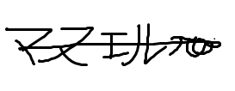

Pablo Aurelio Sánchez Valenzuela: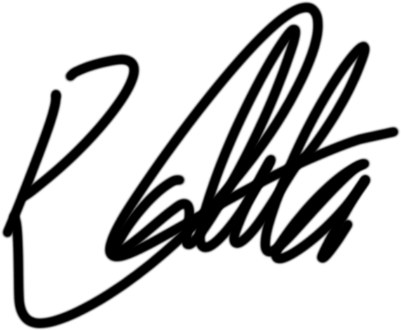

Alejandro Manuel Gestoso Torres:

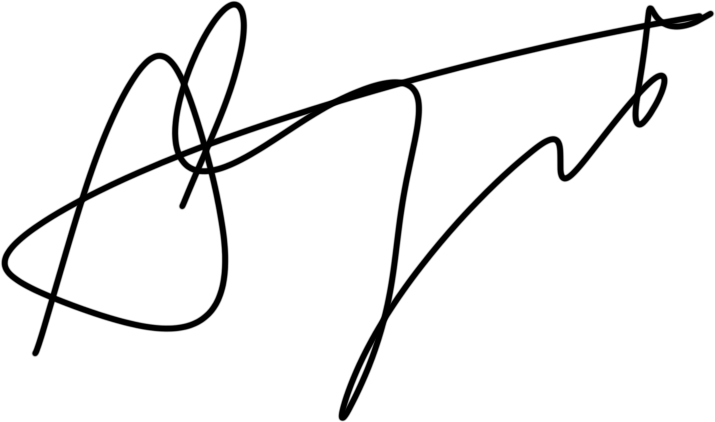

Gregorio Ortega Soldado:

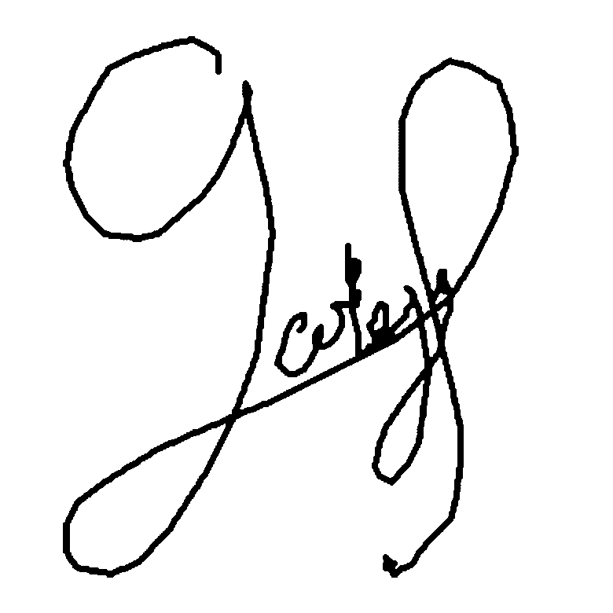

Fernando Claros:

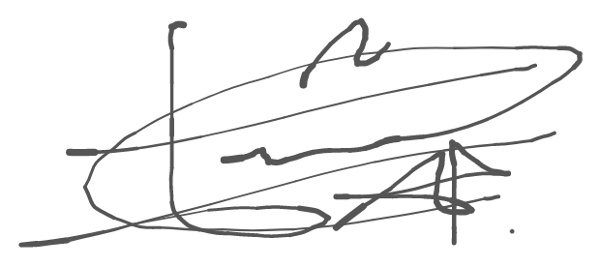

# Conclusions

As a group, we strive to achieve a 9 out of 10 mark at the end of the semester, with help from the poker points assignment methodology and a good work ethic.